Banyule District Cubs Bike Ride

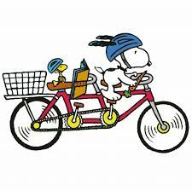
Date: Sunday 20th March 2022

Meeting time: 10.15 for a 10.30 start

Riding from:
The Car park near Diamond Valley Miniature Railway, Eltham Lower Park, Main Road, Eltham

We will be riding along the Main Yarra Trail

- past the Possum Hollow Playground, Beverley Road Heidelberg

Finishing up at Wilson Reserve Ivanhoe
- entry point for collection is the roadway opposite 81 The Boulevard Ivanhoe

Where we will have a sausage sizzle & zooper doopers
there is a $ 2 charge per attendee for the hire of toilet at the end of the ride

Cubs collection at 1.30 pm

Cubs wear uniform and helmet
- Operoo/Caremonkey form acceptance is required.
Please pack (ideally in a backpack):
- Snacks
- Water bottle
- Medications
- Health form
- Sunblock / insect repellent
No Scooters or bikes with training wheels – Cubs need to have a correct sized bike for their own size AND be able to ride properly.

Adult/Youth Helpers are welcome to attend

For Catering & Caremonkey/Operoo Purposes:
*** ALL RESPONSES RE ATTENDANCE ARE TO BE EMAILED TO WAYNE (AKELA) BY TUESDAY 15/3 ***

